**Question 0 (Binomial Distribution):**

**Suppose the shooting success rate of a player is 10%, and it takes at least two success shots to kill the monster. How many times the player need to shoot to have 80% probability of killing the monster?**



**Question 1:**

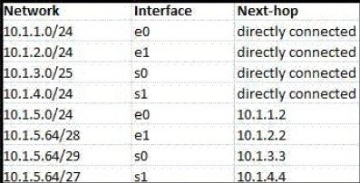

According to the routing table, where will the router send a packet destined for 10.1.5.65? Why?



**Question 2:**

Classless Inter-domain Routing (CIDR) receives a packet with address 131.23.151.76. The router’s routing table has the following entries:

Prefix Output Interface Identifier

131.16.0.0/12 3

131.28.0.0/14 5

131.19.0.0/16 2

131.22.0.0/15 1

The identifier of the output interface on which this packet will be forwarded is ______. Why?



**Question 3:**

Consider the following routing table of a router.

| **PREFIX** | **NEXT HOP** |
| --- | --- |
| 192.24.0.0/18 | D |
| 192.24.12.0/22 | B |

Consider the following three IP addresses, what their next hop will be?

1. 192.24.6.0
2. 192.24.14.32
3. 192.24.54.0

